UNITED STATES
SECURITIES AND EXCHANGE COMMISSION
Washington, D.C. 20549
SCHEDULE 14A INFORMATION
PROXY STATEMENT PURSUANT TO SECTION 14(a) OF THE
SECURITIES EXCHANGE ACT OF 1934
Filed by the Registrant ⌧
Filed by a Party other than the Registrant ◻
Check the appropriate box:
◻Preliminary Proxy Statement
◻Confidential, for Use of the Commission Only (as permitted by Rule 14a-6(e)(2))
◻Definitive Proxy Statement
⌧Definitive Additional Materials
◻Soliciting Material Pursuant to §240.14a-12
AMPHASTAR PHARMACEUTICALS, INC.
(Name of Registrant as Specified In Its Charter)

Payment of Filing Fee (Check the appropriate box):
⌧No fee required.

 | ◻ | Fee paid previously with preliminary materials.
◻Fee computed on table below per Exchange Act Rules 14a-6(i)(4) and 0-11.

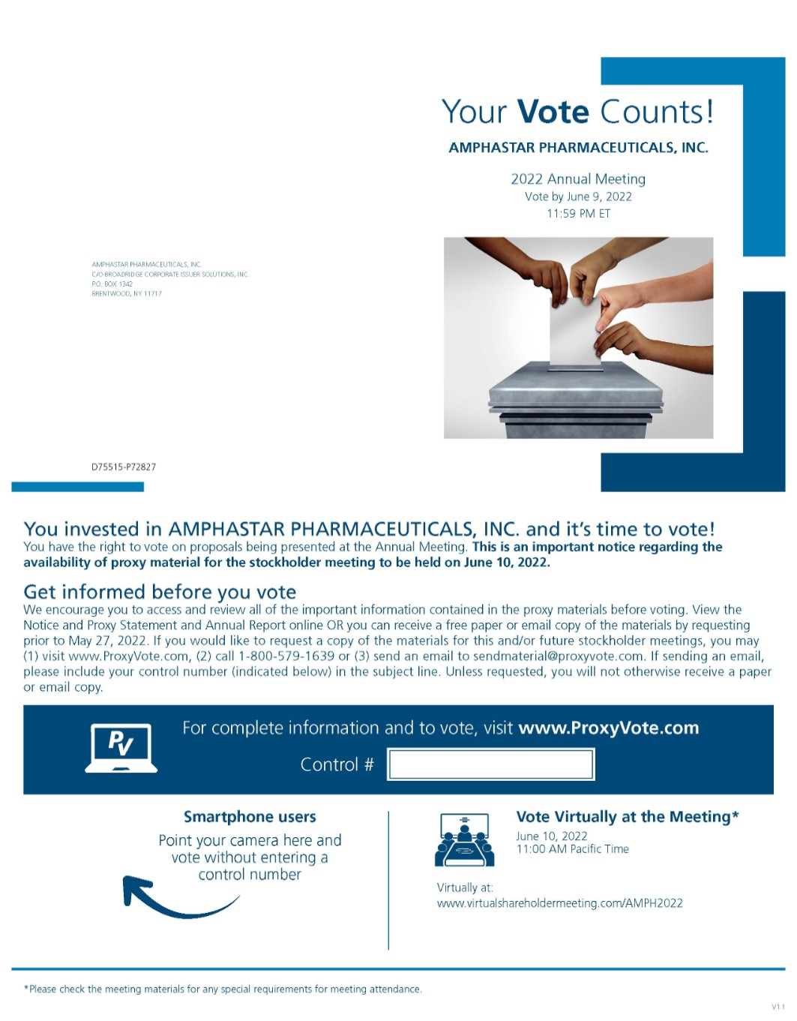 | Your Vote Counts! AMPHASTAR PHARMACEUTICALS, INC. 2021 Annual Meeting Vote by June 6, 2021 11:59 PM ET AMP HAST AR P HAR MACE UT ICALS, INC. C/O BROADRIDGE P.O. BOX 1342 BRENT W OOD, NY 11717 D42479-P54849 You invested in AMPHASTAR PHARMACEUTICALS, INC. and it’s time to vote! You have the right to vote on proposals being presented at the Annual Meeting. This is an important notice regarding the availability of proxy material for the stockholder meeting to be held on June 7, 2021. Get informed before you vote View the Notice and Proxy Statement and Annual Report online OR you can receive a free paper or email copy of the material(s) by requesting prior to May 24, 2021. If you would like to request a copy of the material(s) for this and/or future stockholder meetings, you may (1) visit www.ProxyVote.com, (2) call 1-800-579-1639 or (3) send an email to sendmaterial@proxyvote.com. If sending an email, please include your control number (indicated below) in the subject line. Unless requested, you will not otherwise receive a paper or email copy. Smartphone users Point your camera here and vote without entering a control number Vote Virtually at the Meeting* June 7, 2021 11:00 AM, Pacific Time Virtually at: www.virtualshareholdermeeting.com/AMPH2021 *Please check the meeting materials for any special requirements for meeting attendance. V1 For complete information and to vote, visit www.ProxyVote.com Control #

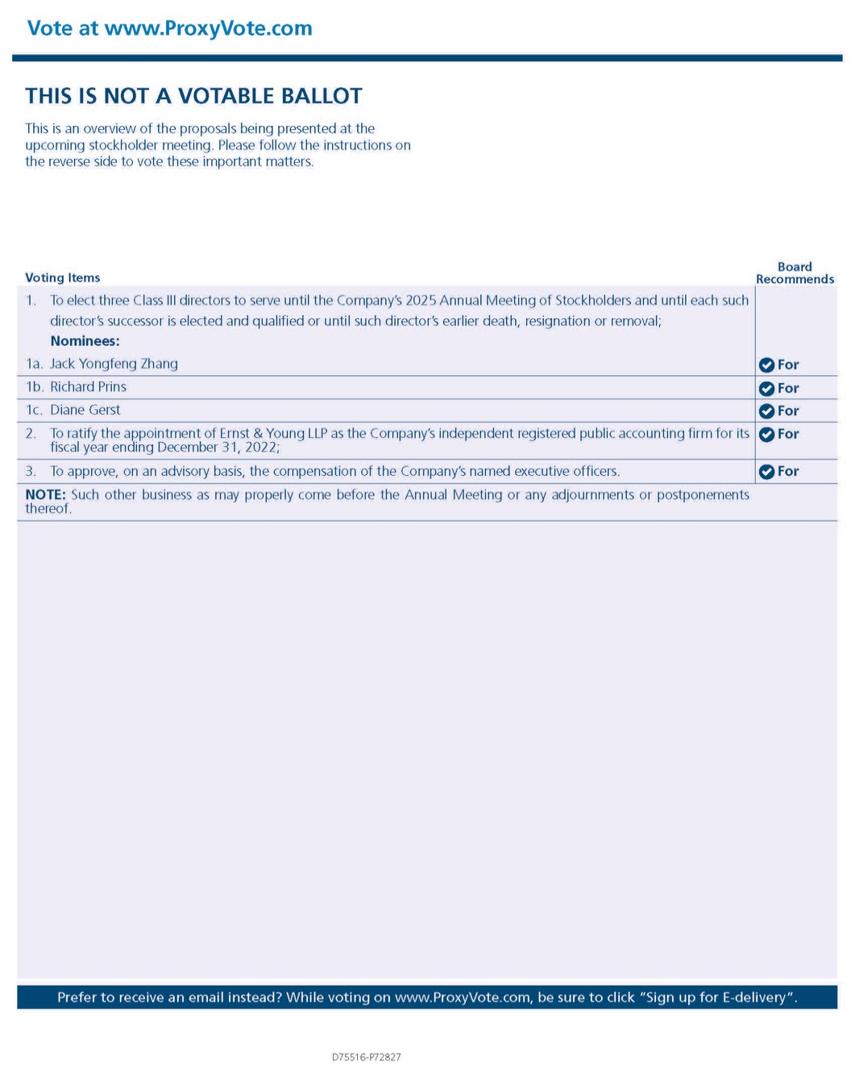 | Vote at www.ProxyVote.com THIS IS NOT A VOTABLE BALLOT This is an overview of the proposals being presented at the upcoming stockholder meeting. Please follow the instructions on the reverse side to vote these important matters. Board Recommends Voting Items D42480-P54849 Prefer to receive an email instead? While voting on www.ProxyVote.com, be sure to click “Sign up for E-delivery”. 1. To elect four Class II directors to serve until the Company’s 2024 Annual Meeting of Stockholders and until each such director’s successor is elected and qualified or until such director’s earlier death, resignation or removal; Nominees: 1a. Mary Ziping Luo For 1b. Howard Lee For 1c. Michael A. Zasloff For 1d. Gayle Deflin For 2. To ratify the appointment of Ernst & Young LLP as the Company’s independent registered public accounting firm for its fiscal year ending December 31, 2021; and For 3. To approve, on an advisory basis, the compensation of the Company’s named executive officers. For Note: To transact such other business as may properly come before the Annual Meeting or any adjournments or postponements thereof.

